**PROJECT DEVELOPMENT - DELIVERY OF SPRINT 2**

|  |  |
| --- | --- |
| Date: | 17 November 2022 |
| Team ID: | PNT2022TMID50586 |
| Name: | Real-Time River Water Quality Monitoring and Control System |

# PYTHON CODE

import time import sys import ibmiotf.application import ibmiotf.device import random

#Provide your IBM Watson Device Credentials organization = "uyyqeq" deviceType = "12345" deviceId = "12345" authMethod = "token" authToken = "12345678"

# Initialize GPIO def myCommandCallback(cmd): print("Command received: %s" % cmd.data['command']) status=cmd.data['command'] if status=="light on":

print ("led is on")

elif status == "light off":

print ("led is off")

else : print ("please send proper command")

try:

deviceOptions = {"org": organization, "type": deviceType, "id": deviceId, "auth-method": authMethod,

"auth-token": authToken} deviceCli = ibmiotf.device.Client(deviceOptions)

#..............................................

except Exception as e:

print("Caught exception connecting device: %s" % str(e)) sys.exit()

# Connect and send a datapoint "hello" with value "world" into the cloud as an event of type "greeting" 10 times

deviceCli.connect()

while True:

#Get Sensor Data from DHT11

temp=random.randint(90,110) Humid=random.randint(60,100)

data = { 'temp' : temp, 'Humid': Humid }

#print data def myOnPublishCallback(): print ("Published Temperature = %s C" % temp, "Humidity = %s %%" % Humid, "to IBM Watson") success = deviceCli.publishEvent("IoTSensor", "json", data, qos=0, on_publish=myOnPublishCallback) if not success:

print("Not connected to IoTF")

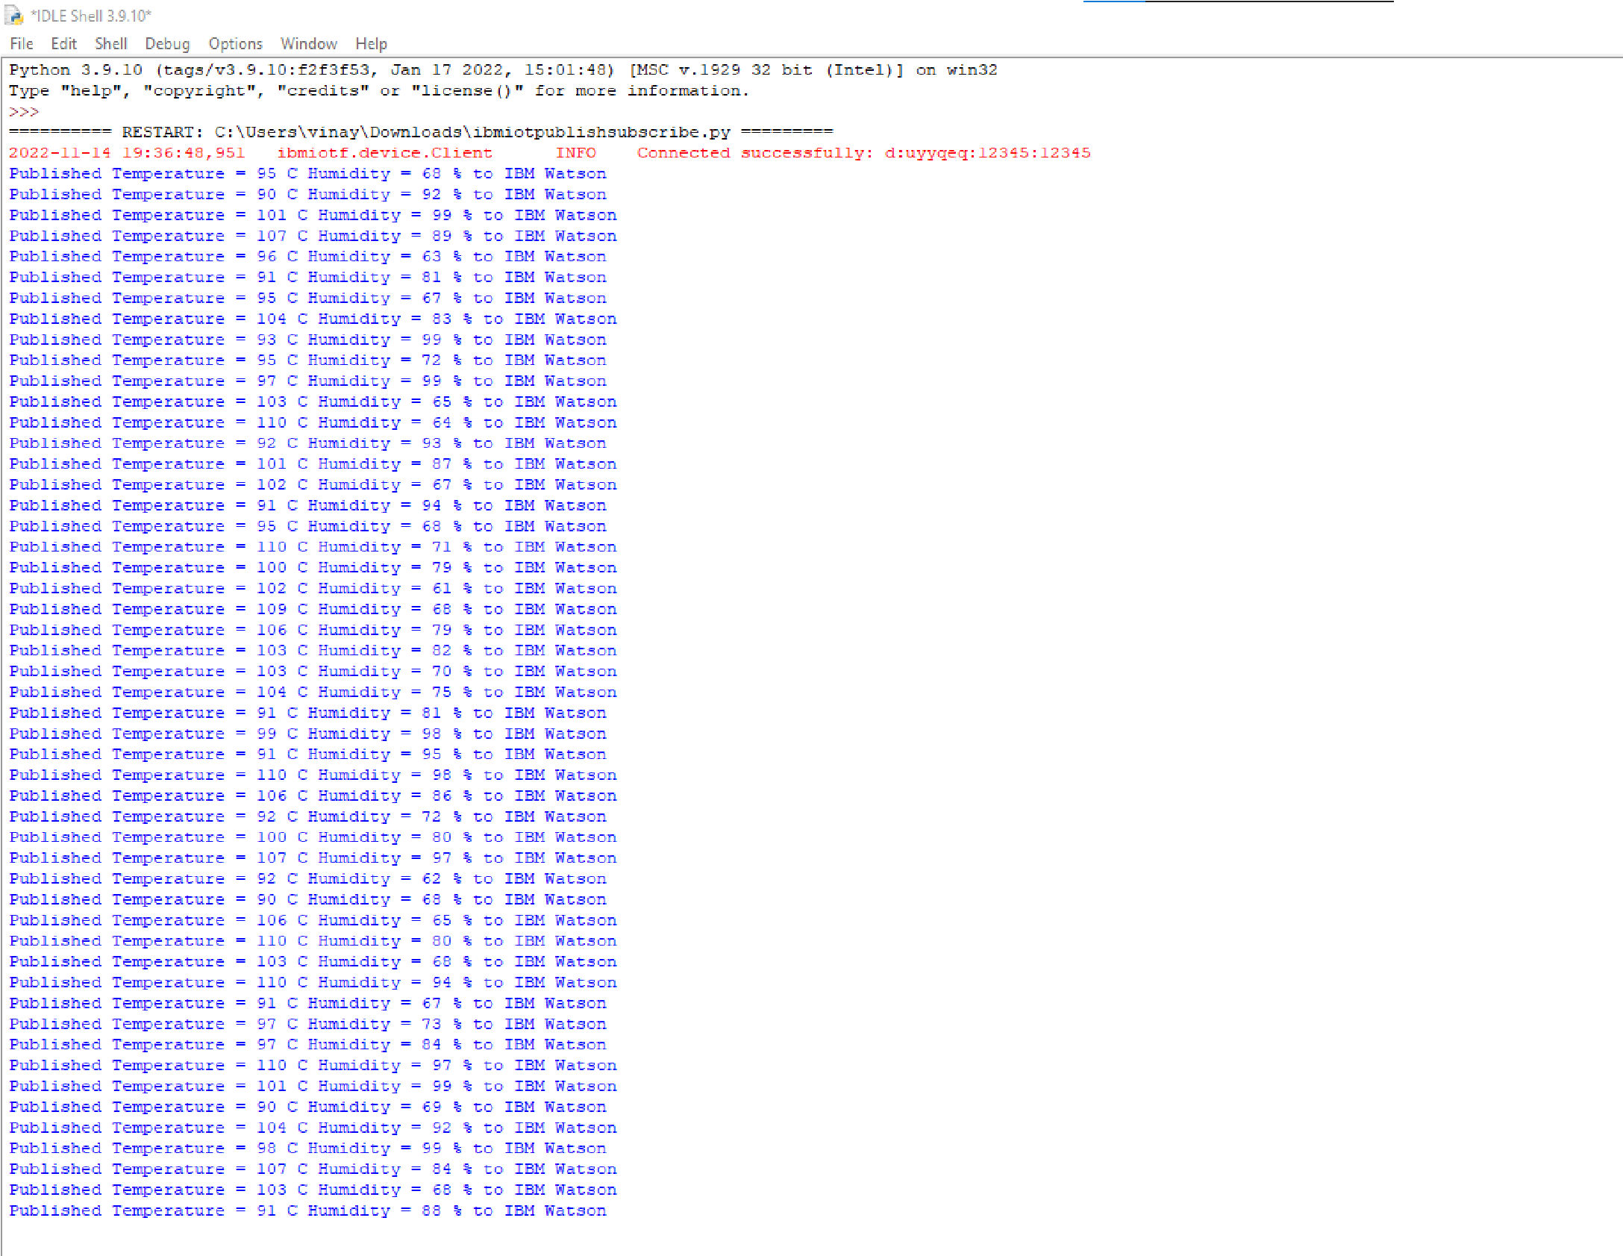time.sleep(10) deviceCli.commandCallback = myCommandCallback

# Disconnect the device and application from the cloud deviceCli.disconnect()